FutureDial Guide to Prepare Android Devices for GreenT and iRT Stations

This document outlines the recommended procedure for preparing an Android Device for reading and clearing. The process is the same for both iRT and GreenT

About Android USB Debugging

The primary function of this mode is to facilitate a connection between an Android device and a computer with Android SDK (Software Development Kit) so commands can be issued via software after connecting the device directly to a computer via USB. In some versions of Android, this is also known as Developer Mode.

Why Does FutureDial Need USB Debugging Turned On?

FutureDial utilizes the Android Device Bridge to uniquely identify an Android Device serial number, so FutureDial’s software can issue commands directly to the Android device. FutureDial installs a small application onto the Android device that facilitates the reading of device information in order to report that information back to iRT and GreenT. This application is immediately removed from the device after collecting the information. Specifically with GreenT, another small application is installed on the Android device that will invoke a system reset, thereby clearing the Android device of all user data, and reverting it back to Manufacturer default settings, including turning off USB Debugging.

The Following Must Be Done BEFORE Connecting the Android Device

How to Enable USB Debugging
This process is slightly different between versions of Android, and the UI is slightly different between manufacturers, as well as devices. Below is the generic, high level instructions:
development.

- On most devices running Android 3.2 or older, you can find the option under Settings > Applications > Development.
- On Android 4.0 and newer, it's in Settings > Developer options.
- On Android 4.2 and newer, Developer options is hidden by default. To make it available, go to Settings > About phone and tap Build number seven times. Return to the previous screen to find Developer options.

Example of Developer Options Screen on an Android Device:

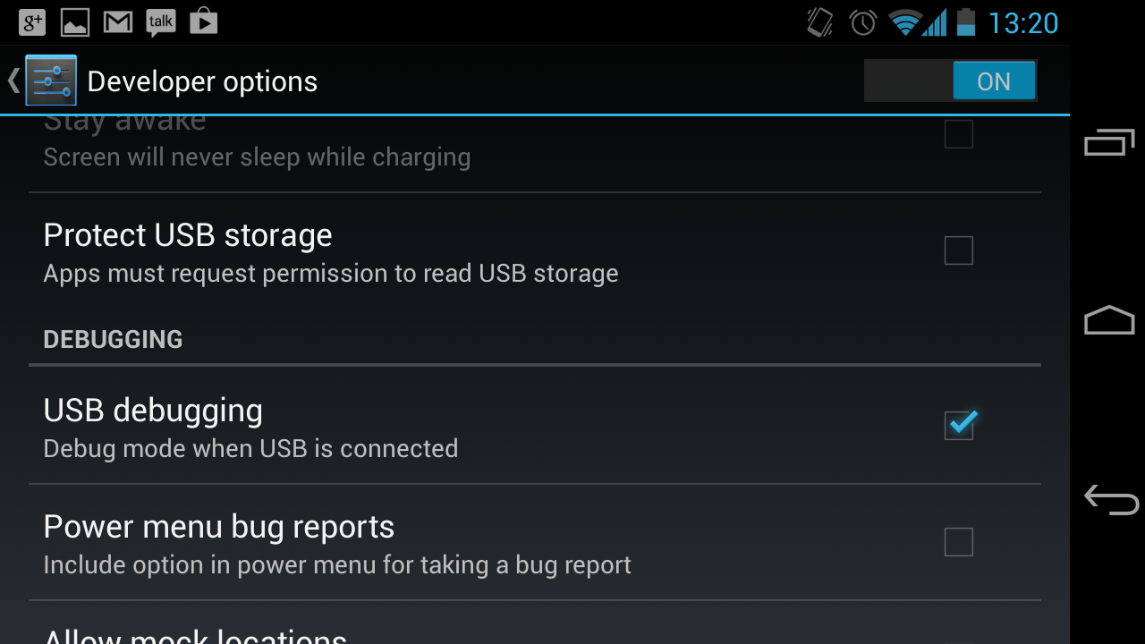

After enabling USB debugging on the device, the device can then be connected to the iRT/GreenT station.

If the device is running Android version 4.2 and above, upon connecting the device, you will see an alert on the device requesting permission for USB debugging from this computer:

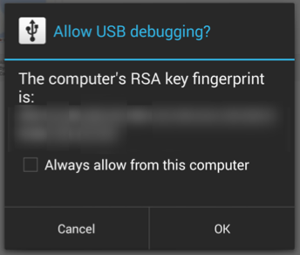

Check Always allow from this computer and click OK.

Additional Security Prompts
FutureDial installs applications onto the Android device during the information reading and content clearing of the device. After the initial connection, some devices will show additional pop-ups on the device asking for confirmation of installation. Please click okay or allow to move forward with the information read and content clearing of the Android device.

Other Ways of Enabling USB Debugging
With some devices, there are other ways to enable USB Debugging. If the above method is not desirable, then the following can be used instead.

Samsung Devices (Verizon Only)

The following steps can be performed on Samsung Devices to enable USB Debugging:

- Open the phone dialer and type ##366633#
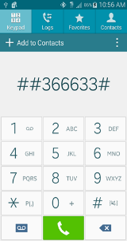
- Select Enable DM Mode from DM Mode menu
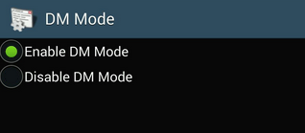
- In the Developer options menu click on Revoke USB debugging authorizations
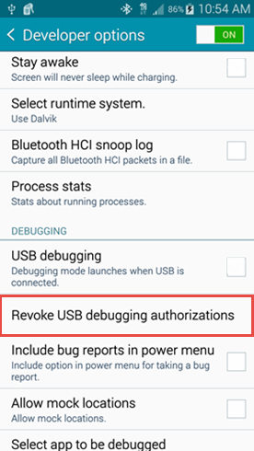
- Select OK on the pop-up that appears

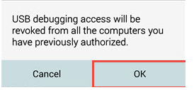

- Select USB debugging from Developer options menu
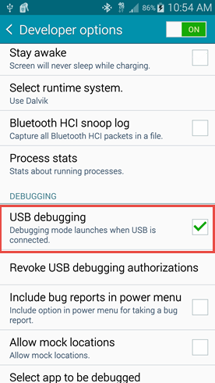
- Select OK on pop-up
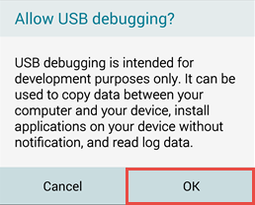
- Select Stay awake from Developers options menu then return to home screen
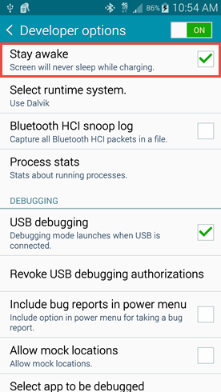
- Once the phone is back to Home screen connect the phone to the iRT/GreenT station.

- When the RSA Fingerprint pop-up is displayed, make sure Always allow this computer is checked, then click OK


